**SYLLABUS CHECKER**

**Final Project Report**



**TEAM**

Jack Demtshuk, Ishaq Halimi, Joscelin Montoya-Rojas, Rebecca Nanayakkara, Nicholas Taweel

**CLIENT**

Dr. Judith Ozment

Division Head of Science and Engineering

[o96@psu.edu](mailto:o96@psu.edu)

# **INDIVIDUAL CONTRIBUTIONS BREAKDOWN**

* Jack Demtshuk - Developed PDF input and text-extraction functionality; created the keyword/phrase dictionary for sentence-transformer search; refined GUI layout and report output; implemented recommendation text for missing syllabus sections; general quality updates; converted project to exe file.
* Nicholas Taweel - Developed the initial GUI framework and file-selection workflow; contributed to testing and debugging.
* Rebecca Nanayakkara - Introduced the sentence transformer CrossEncoder semantic search functionality; implemented readability functionality; added interpretive feedback and recommendations for readability; created the excel spreadsheet documentation for testing; contributed to accuracy testing of the output.
* Joscelin Montoya-Rojas - Conducted testing; assisted with refinement of keyword/phrase dictionary; documented errors, misclassifications, and bugs.
* Ishaq Halimi - Implemented final version of GUI interface; performed additional testing on content-analysis and readability results; supported debugging and helped verify reported issues.

**TABLE OF CONTENTS**

**Individual Contributions ............................................................................................ 2**

**Section I – Problem Statement ............................................................................................ 5**

**Section II – Related Work ............................................................................................ 6**

**Section III – Features ............................................................................................ 7**

3.1 Functional Requirements & Non-Functional Requirements **....................... 9**

3.2 User Stories **.................................................................................................. 10**

3.3 Use Case Diagram(s) **................................................................................... 11**

**Section IV – Design Specification ................................................................................ 14**

4.1 ER Diagram **.................................................................................................. 14**

4.2 UML Class Diagram **.................................................................................... 15**

4.3 User Interface Design **................................................................................... 16**

**Section V – Implementation Details ........................................................................... 17**

5.1 Steps/Procedures Required to Develop the Program **.................................. 17**

5.2 Required Tools and Technologies **............................................................... 28**

5.3 Development Timeline **................................................................................ 29**

**Section VI – Test Strategy Applied ............................................................................. 31**

6.1 Unit Testing **............................................................................................... 31**

6.2 Integration Testing **..................................................................................... 32**

6.3 System Testing **........................................................................................... 32**

**Section VII – Discussion ............................................................................................ 33**

7.1 Unresolved Issues **...................................................................................... 33**

7.2 Limitations **................................................................................................ 34**

7.3 Future Work **.............................................................................................. 36**

**Section VIII – Conclusion ......................................................................................... 37**

**References ................................................................................................................. 38**

**Appendix ................................................................................................................... 39** Appendix A – ReadMe / Installation Instructions **.......................................... 39**

Appendix B – Software Snapshots **................................................................. 40**

Appendix C – Client Evaluation Letter **......................................................... 49**

# 

## **SECTION I: Problem Statement**

A syllabus is one of the most important documents a student receives, yet its quality and completeness can vary widely from course to course. Missing grading policies, unclear attendance expectations, or outdated accessibility statements can leave students confused and unprepared. Faculty at Penn State Abington are required to follow the detailed guidelines outlined in the Faculty Handbook, but checking every syllabus against these requirements can be time consuming and inconsistent. Current tools like Grammarly may help with grammar, but they cannot determine whether a syllabus contains all the elements that students and administrators expect.

The Syllabus Checker aims to solve this problem by providing an automated system that evaluates syllabi for both compliance and clarity. Our tool will go beyond grammar checks by identifying missing or outdated content, assessing readability, and generating actionable recommendations for improvement. In doing so, it supports instructors in creating documents that not only meet institutional policies but are also student friendly and accessible.

By automating this process, the project offers benefits across the board. Students will receive clearer, more reliable syllabi that help them plan and succeed in their classes. Faculty will save time and reduce the stress of manual reviews, while administrators can be confident that institutional standards are consistently met. In short, the Syllabus Checker will raise the overall quality of syllabi and improve the academic experience for everyone involved.

## **SECTION II: Related Work**

When it comes to checking documents such as syllabi, there are already some tools out there that can handle parts of the job, but none of them really cover everything we are aiming for. For example, while Grammarly is great at catching grammar mistakes and spelling errors, it doesn’t know what specific content a syllabus is supposed to have. Grammarly won’t flag your syllabus if something important is missing, such as the grading policy, office hours or accessibility statements.

At our university, faculty have access to Appendix E of the Faculty Handbook, which lays out very detailed syllabus guidelines. These policies specify exactly what must be included, such as instructor contact information, office hours, attendance expectations, and more. In addition, according to the Faculty Handbook, copies of all syllabi have to be submitted to the professor’s division head within the first ten days of the semester. This means that reviewing these syllabi can be time consuming and requires a lot of responsibility for each syllabi to be manually checked for the required details.

This is where our project is different. The Syllabus Checker combines the strengths of existing tools while also focusing specifically on what makes a syllabus complete and student friendly. Our tool will not only fix grammar, it will look for required information, flag outdated content, and give recommendations on how to make the syllabus more readable. Ultimately, our tool is designed to support both professors and students, while also saving time for administrators who are responsible for reviewing syllabi.

## **SECTION III: Features**

The Syllabus Checker is an analysis tool designed to evaluate Penn State Abington syllabi for completeness, clarity, and policy compliance using Penn State Abington’s institutional standards. The program operates exclusively on PDF files and performs content validation, semantic analysis, and readability evaluation. All required syllabus components enforced by the program are derived directly from Appendix E of the Penn State Abington Faculty Handbook, which defines the mandatory and recommended elements for undergraduate syllabi. These institutional expectations include instructor contact information, course materials, course content and expectations, location and meeting times, course goals and objectives, grade breakdown, examination policy, attendance policy, academic integrity statement, counseling services, disability resources, educational equity statement, and a campus closure policy. Each syllabus is first validated by file type and filename format, then automatically parsed to extract course code, instructor name, and semester to ensure proper identification before content analysis begins. The program extracts readable text from every page of the uploaded document, ensuring that no content is overlooked, while files with invalid naming conventions will throw an error to the user, informing them that the PDF is in an incorrect naming format.

To detect whether required syllabus components are present, the program does not rely on fixed headings or keywords. Instead, it uses a semantic similarity model (specifically the SentenceTransformers CrossEncoder model) which has been pre-trained on millions of sentences, to score how well each sentence in the syllabus matches a set of policy-related query phrases. For implementation, we first split the full syllabus text into individual sentences and store them in a list. Then, for each required section, we created a search dictionary that maps the section name (for example, “Grade Breakdown” or “Attendance Policy”) to a list of short phrases that instructors might reasonably use to describe that content, such as “grade breakdown”, or “grading scale” for Grade Breakdown. For every one of these phrases, the program pairs the phrase with every sentence in the syllabus and passes all of those (phrase, sentence) pairs into the CrossEncoder model at once. The model returns a numeric relevance score for each pair, which we convert into a probability using a sigmoid function. The probability is then compared to a tuned threshold. If the probability for that section meets or exceeds the threshold, the section is marked as “found” and ten points are added to the syllabus’s content score. If it falls below the threshold, the section is treated as “not found”.

Each required section is scored independently using this probability-based matching. The total content score is computed by summing the points from all sections that are successfully detected, and the tool then assigns an overall content grade such as Excellent, Great, Good, Adequate, or Incomplete, depending on how many Appendix E requirements are satisfied. A detailed Content Analysis Report is generated that lists all required components, marks those that were found and not found, and produces targeted recommendations for every section that was not found. In addition, for each section that is successfully detected, the system generates positive feedback (“kudos”) describing what the instructor did well, providing validation for components that already meet institutional expectations.

In addition to content coverage, the Syllabus Checker performs a full readability evaluation to measure how clear, accessible, and appropriate the syllabus is for its intended academic level. The course number in the filename is parsed to determine whether the course is introductory, immediate, or advanced. Based on this classification, the system applies distinct readability expectations using three professional metrics: the Flesch Reading Ease score to evaluate clarity and flow, the Flesch–Kincaid Grade Level to assess whether the difficulty level fits the course number, and the Gunning Fog Index to analyze vocabulary complexity and sentence density. Each metric has customized thresholds depending on course level, ensuring that introductory courses remain accessible while advanced courses are allowed greater complexity. The program produces an overall readability rating using a color-coded system, followed by interpretive feedback that translates numerical scores into practical guidance. Strengths are highlighted through “What you did well” messaging, while weaknesses are accompanied by specific recommendations such as simplifying language, splitting long sentences, reducing density, or adding discipline-specific terminology when appropriate.

The output of the tool is structured into clearly labeled sections designed for faculty use: a Content Analysis Report, a Final Grade Summary, a Missing Sections list with policy-based recommendations, a Readability Report with interpretation and guidance, and a Kudos section acknowledging strong syllabus components. In addition to viewing results directly in the interface, the program allows users to export the entire analysis as a formatted PDF report, making it easy to save, print, or share results for documentation or revision purposes. The interface is intentionally minimal and requires only a PDF upload, making the system accessible to faculty with no technical background. By combining policy enforcement from Appendix E, semantic matching through a CrossEncoder model, course-level-specific readability analysis, and report generation into one tool, the Syllabus Checker provides instructors with feedback that improves clarity and compliance with Penn State Abington’s academic standards.

**3.1 Functional Requirements & Non-Functional Requirements**

Functional Requirements

* Users can upload PDF syllabi.
* The system extracts and processes text.
* The system identifies required content sections.
* The system calculates readability metrics (FRE, FK Grade, Gunning Fog).
* The system flags missing or insufficient sections.
* The system provides suggestions for improvement.
* The system displays final scoring and analysis in a GUI.
* The system detects filename formatting concerns.
* The system allows the analysis report to be saved as a PDF.

Non-functional Requirements

* Usability: Easy-to-use GUI for non-technical users.
* Performance: Processes typical syllabi in ~20 seconds.
* Portability: Runs locally on Windows/macOS.
* Maintainability: Section libraries/dictionaries should be easy to update.
* Accuracy: Must detect at least 85% of required sections.
* Reliability: Handles irregular or partially scanned PDFs.
* Security: All files remain local to the user’s device.

**3.2 User Stories**

1. As a professor, I want to upload my syllabus as a PDF so that I can verify it contains all required Penn State sections.
2. As a professor, I want the system to flag missing or incomplete content so that I know what needs revision before submission.
3. As a professor, I want readability feedback so that I can ensure my syllabus is clear and accessible for students.
4. As a professor, I want to receive suggestions for improvement so that I can easily update and strengthen my syllabus.
5. As a professor, I want to see a final score or pass/fail evaluation so that I can quickly understand whether my syllabus meets institutional expectations.

**3.3 Use Case Diagrams**

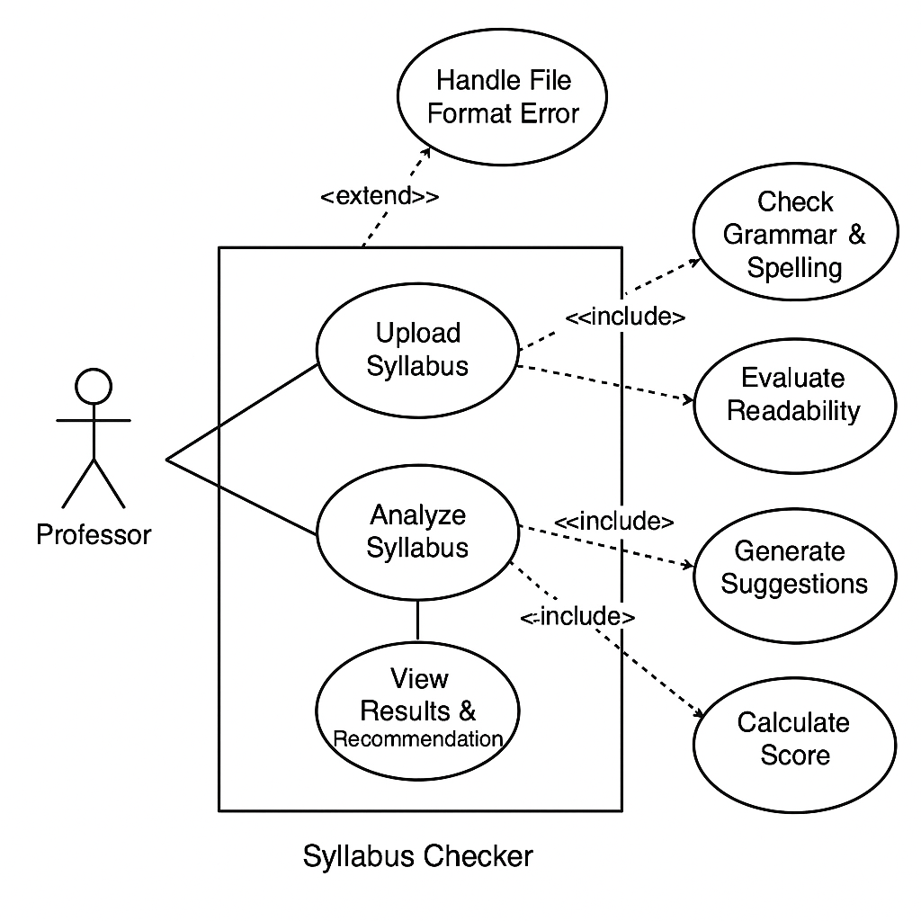

**Figure 1. Use Case Diagram for the Syllabus Checker**

This diagram breaks down the system's main analysis process into smaller steps, such as checking readability, detecting required content, and generating suggestions. It also shows how a file format error extends from the upload process. This gives a clearer view of what happens inside the system when a professor analyzes a syllabus.

Structural Diagram

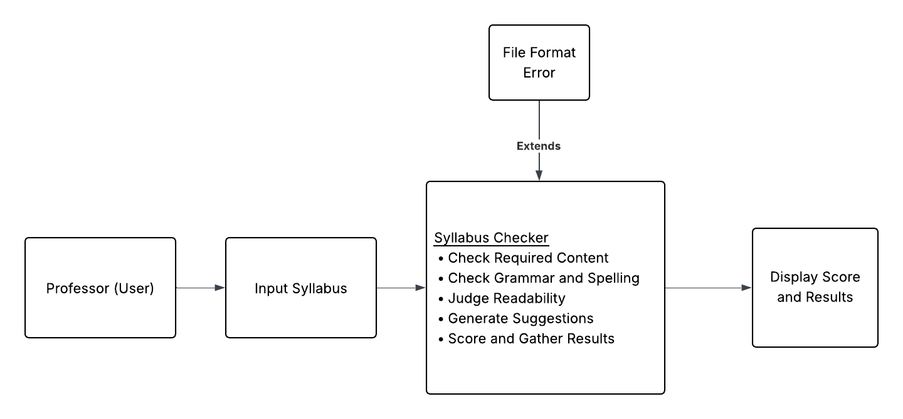

**Figure 2. Structural Diagram**

The use case situation involves the professor inputting a syllabus into the syllabus checker, where the program then judges the content and quality of the syllabus. A file format error may be raised, which is an extension of the syllabus check step. Given that no error occurs, the syllabus checker will display a score and suggestions.

## **SECTION IV: Design Specification**

**4.1 ER Diagram**

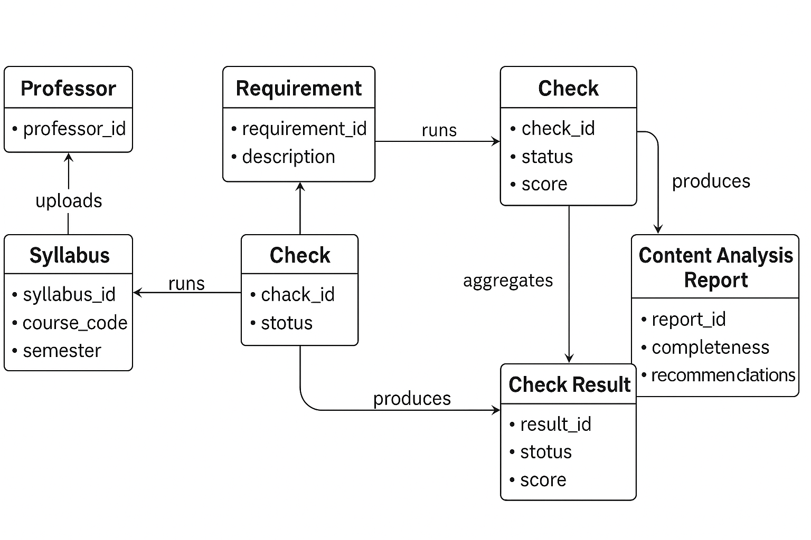

**Figure 3. ER Diagram - Core Data Relationships in the Syllabus Checker**

The ER diagram above illustrates how data flows through the Syllabus Checker system. A Professor uploads a syllabus, which is associated with a specific course. Each syllabus is evaluated against a set of requirements defined by the university’s Faculty Handbook and Appendix E. These requirements generate corresponding checks that analyze the syllabus for completeness and accuracy.

Each Check produces a Check Result, which captures details about whether the required information was found, missing, or outdated. These individual results are then accumulated into a content analysis report, which summarizes the overall syllabus quality, readability, and compliance with institutional guidelines. The requirement entity also informs the final report by providing the context for each evaluation criterion. This structure ensures that every syllabus is assessed systematically and that feedback is accurate, transparent, and consistent across all courses.

**4.2 UML Class Diagram**

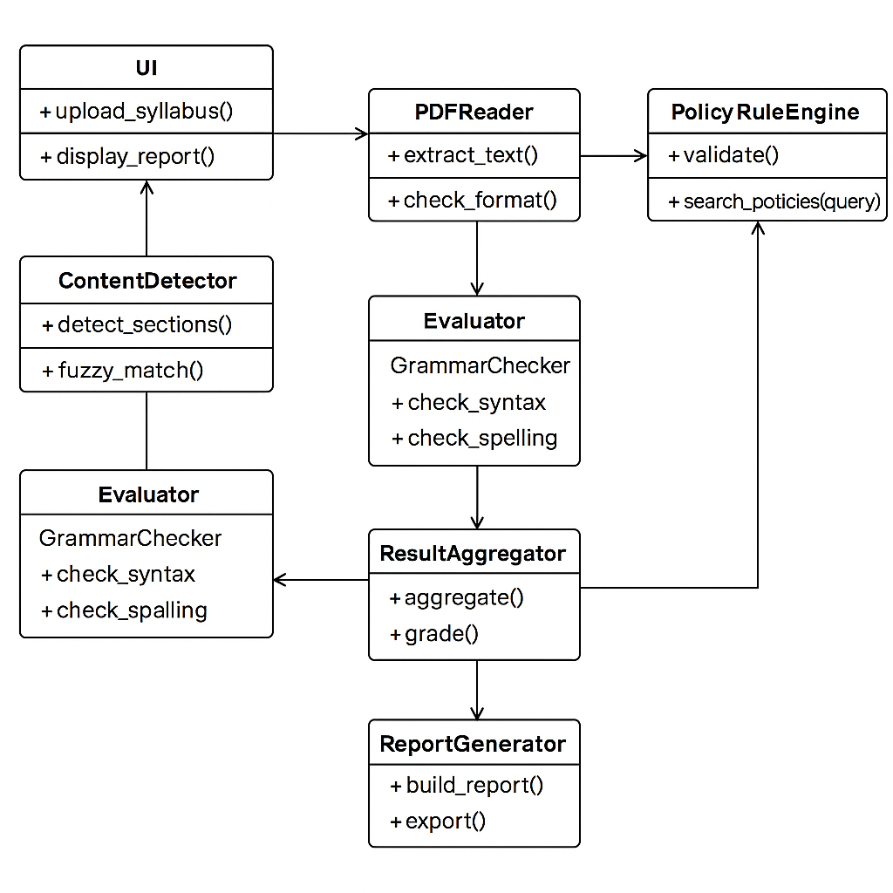

**Figure 4. UML Class Diagram - Core Program Architecture of the Syllabus Checker**

The UML Class Diagram illustrates the structural design of the Syllabus Checker system and how its classes interact. The UI class enables professors to upload syllabi and view results. The PDFReader class extracts text and validates the file format, while the ContentDetector identifies required sections through fuzzy matching. The PolicyRuleEngine validates content against institutional policies, and the Evaluator (which includes the GrammarChecker) reviews syntax and spelling for clarity.

Outputs from these modules are compiled by the ResultAggregator, which calculates a completeness score and summary data. The ReportGenerator then creates a final content analysis report displayed through the user interface. This modular design supports easy maintenance, scalability, and clear organization of system responsibilities.

**4.3 User Interface Design**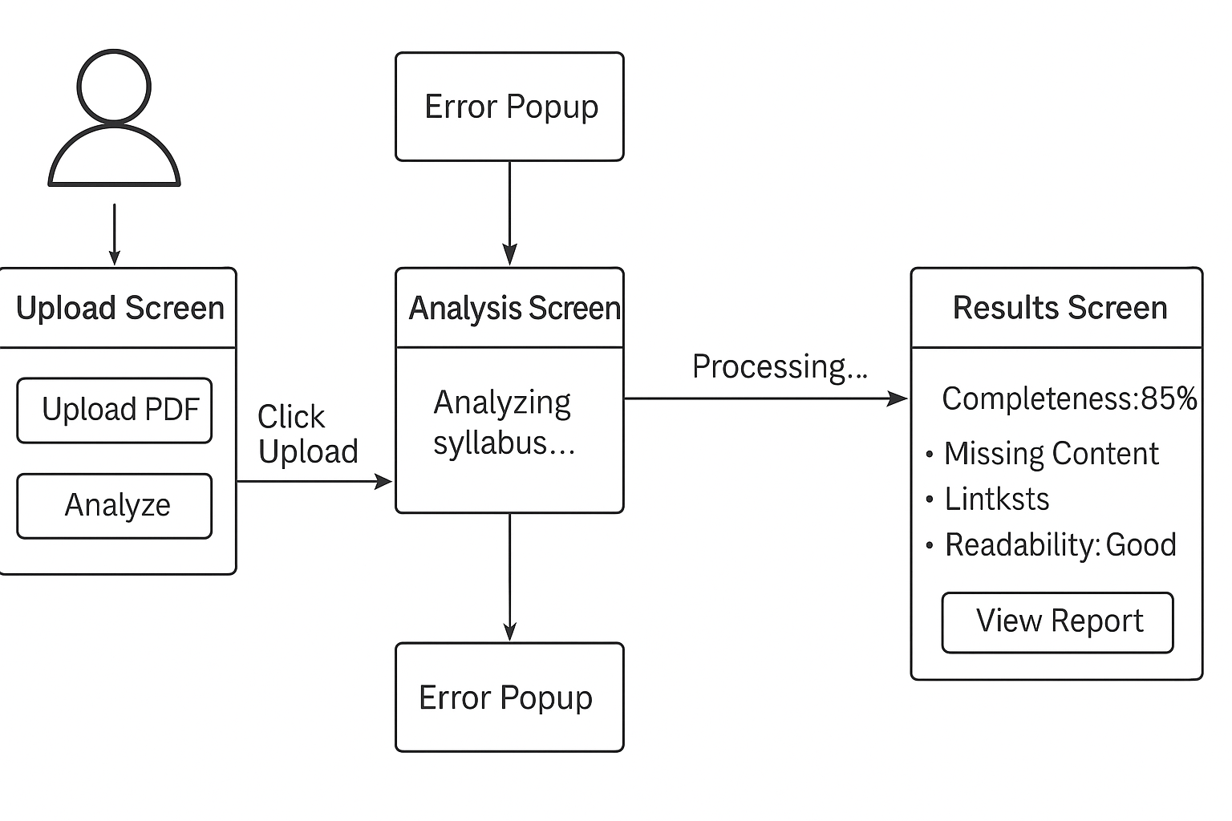

**Figure 5. User Interface Diagram - Screen Flow of the Syllabus Checker**

The User Interface Diagram illustrates the user interaction flow for the Syllabus Checker system. The process begins with the upload screen, where the professor selects and uploads a syllabus file. If the uploaded file is not in the correct format (for example, not a PDF), an error popup appears to notify the user. Once a valid file is uploaded, the system transitions to the analysis screen, which displays the progress of the syllabus evaluation, including content verification, grammar and spelling checks, and readability assessment.

After the analysis is complete, the program navigates to the results screen, which presents a comprehensive report including the syllabus completeness score, missing sections, readability score, and actionable recommendations for improvement. The layout is designed with simplicity and clarity in mind, ensuring that professors can easily interpret results and make necessary adjustments to their syllabi.

## **SECTION V: Implementation Details**

**5.1 Steps/Procedures Required to Develop the Program**

To build the syllabus analyzer, we decided to split this into two main parts:

1. A backend function that performs all analysis on the PDF
2. A Tkinter GUI class that imports and calls the function

Backend Procedures

1. Import and configure required libraries.
   * PdfReader for extracting text from PDFs
   * os for checking the file path and reading the filename
   * CrossEncoder for semantic scoring
   * re for sentence splitting
   * numpy for converting logits into probabilities
   * textstat for readability metrics.

File Validation - Before doing anything, the program checks that the file actually exists and ends in .pdf. If the file is missing or the wrong type, the program will stop and return an error message instead of attempting to analyze it.

PDF text extraction - Using PdfReader, the program loops through each page and calls extract_text(). All extracted text is stored in a single string. If a page has no readable text (common for scanned pages), the program adds a placeholder like [No Text Found] so the final report reflects exactly what was and wasn’t readable.

Sentence splitting - The combined text is broken into separate sentences using regular expressions. Extremely short lines or lines with no real words are removed so the next step only runs on useful sentences.

Readability analysis - The program calls textstat to calculate:

* Flesch Reading Ease - This score measures how easy a passage is to read. Higher scores indicate simpler, more readable text, while lower scores suggest more complex material. The formula for this test is:

**206.835 – 1.015(total words ÷ total sentences) – 84.6(total syllables ÷ total words)**, which is commonly used in education and publishing to evaluate the general readability of written content *(Kincaid et al., 1975)*.

* Flesch-Kincaid Grade Level - This index uses the same underlying concepts as the Flesch Reading Ease score, but instead of producing a readability score, it converts the result into an estimated U.S. grade level. It is commonly used by teachers, parents, and educational institutions to assess whether a text is appropriate for a specific age group. The formula for this test is:

**0.39(total words ÷ total sentences) + 11.8(total syllables ÷ total words) – 15.59** *(Kincaid et al., 1975)*.

* Gunning Fog Index - This is a readability test for English writing. The resulting index estimates the years of formal education a person needs to understand the text on the first reading. The function determines “complex” words as words consisting of three or more syllables, and does not include proper nouns, familiar jargon, or compound words (such as -es, -ed, or -ing) as a syllable. The formula for this test is:

**0.4 [(words ÷ sentences) + 100 (complex words ÷ total words)]**,

which has been widely used in journalism and education to measure text difficulty *(Gunning, 1952)*.

The readability component of the tool was recently redesigned to be far more accessible for faculty. Instead of showing raw readability metrics like Flesch Reading Ease or Gunning Fog scores directly, the system now translates those numerical results into a user-friendly “READABILITY REPORT” written in plain language. This report focuses on three aspects: clarity and flow, appropriateness for course level, and the overall word complexity. The report provides tailored hard-coded explanations that help faculty understand how their syllabus reads from a student’s perspective.

To support this, we implemented course-specific readability expectations. Because a 100 level syllabus should not be held to the same complexity standards as a 400-level course, the tool automatically determines the course level by inspecting the normalized course number. For example, courses such as BIO_004 or ENG.101 are evaluated with the thresholds defined for level 0 and 1, while CMPSC_463 is evaluated with the threshold defined for level 4. If the first digit of the course number falls outside our supported set (0-4), the tool stops and notifies the user that the course level is unsupported.

Each course level has its own ideal readability ranges for three underlying metrics (flesch-reading ease (FRE), flesch kincaid-grade (FK), and gunning fog (FOG)). Rather than showing these numeric values, the tool interprets them and writes an explanation that tells the professor what they did well and what they might need to improve. For instance, in the clarity section, the system might comment on whether the syllabus flows smoothly, whether sentences feel too dense, or whether the writing may benefit from shorter or more structured formatting. In the course-level appropriateness section, faculty receive feedback about whether the tone, depth, and academic wording align with what is typical for that level. Finally, the complexity section explains how word choice and sentence structure affect perceived difficulty, again with course-specific expectations in mind.

The new readability report does not overwhelm instructors with technical statistics; professors will not see FRE, FK, or FOG values. Instead, they receive structured guidance such as “What you did well,” followed by actionable recommendations that are directly matched to the performance of their syllabus. If a syllabus meets all three internal checks, the report provides positive reinforcement and avoids unnecessary suggestions. If one or more categories indicate difficulty, the tool recommends ways to improve clarity, reduce sentence heaviness, or rebalance academic tone. For syllabi that struggle across most of the statistical tests, the report concludes with broader recommendations, such as adding clear section headers or breaking up dense paragraphs.

Overall, the readability system now feels supportive and more user-friendly. It uses the underlying metrics to drive interpretation but presents results in a format that mirrors how faculty naturally think about writing: clarity, level-appropriateness, and student accessibility. This makes the report easier to understand and more effective for revision, especially since expectations shift automatically depending on whether the syllabus belongs to a 100, 200, 300, or 400 level course.

Semantic Detection of Required Syllabus Sections -

After the PDF text is split into sentences, the program loads a pretrained CrossEncoder model from the sentence-transformers library. A CrossEncoder is a type of deep learning model designed for semantic similarity, which means it can determine how closely two pieces of text relate in meaning.

This specific model has already been trained on millions of text pairs from large-scale datasets. During training, the model learned patterns about how real sentences relate to questions, instructions, and statements. Because of this, the model can recognize syllabus information even if the wording is not an exact match.

In this program, each required syllabus section is represented by a short query string like:

“Grade Breakdown: grading policy grade distribution grading scale”

The algorithm works like this:

1. The program takes the query string and pairs it with every sentence extracted from the syllabus.
2. Each pair is fed into the CrossEncoder at the same time (query + sentence).
3. The model outputs a logit score, which is a raw numeric value that represents how strong the semantic similarity is.
4. These logits are converted into probabilities using the sigmoid function, which gives a value between 0 and 1, where numbers closer to 1 mean a stronger match.
5. For each required section, the program looks at the highest-scoring sentence in the entire document:
   1. If the highest probability is above the threshold (currently set as 0.05), the system declares that the syllabus contains the section.
   2. If all probabilities are below that threshold, the section is marked missing.

Scoring and Output Formatting - Once every required section has been evaluated, the program calculates a score:

* +10 points for each required section that the model marked as found.
* Readability penalties (-5 or -10) are applied only when the scores show extremely difficult reading levels.

After scoring is complete, the backend generates one formatted text report. The final output includes:

1. Course information extracted from the filename
2. Readability results and explanations of what they mean.

* We used sources to determine our interpretation of the readability scores. For Flesch reading ease, Wikipedia provides this scoring table:

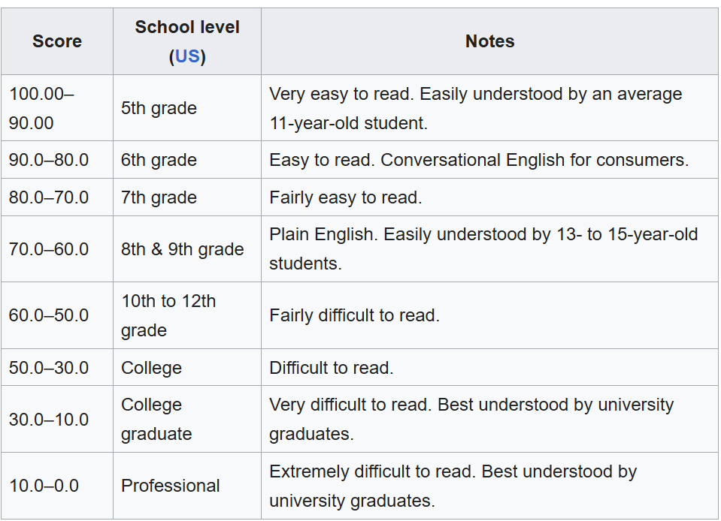

**Figure 6. Flesch Reading Ease Scoring Table**

**(*Source: “Flesch Reading Ease,” Wikipedia (2024))***

Therefore, from the table, we can see that the appropriate score should be in the range of 30-50, where all values above 50 are very easy to read (but no penalty), values between 10-30 are at a college graduate level (-5 penalty), and values under 10 are at a professional level (-10 penalty).

* Readable provides this scoring table for flesch-kincaid grade level:

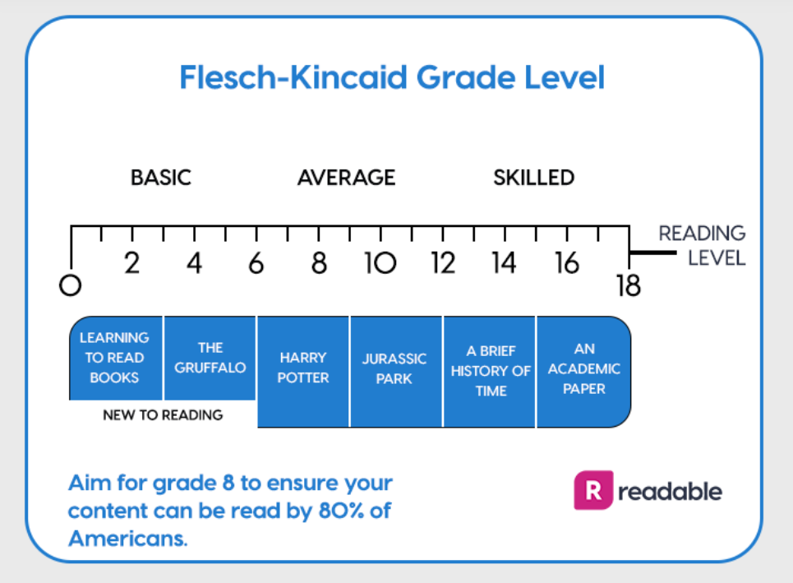

**Figure 7. Flesch-Kincaid Grade Level Interpretation Chart**

*(Source: Readable.com (2024)*

From this table, we can determine that below 12 should be below a college level, and above 18 would be past college level. Therefore, our scoring should issue a penalty for scores above 18. It should also notify the user that they are in the appropriate level when the score is between 12 and 18, and should notify users that their text is below college level when less than 12, but issue no penalty.

* Wikipedia provides this scoring table for gunning fox index:

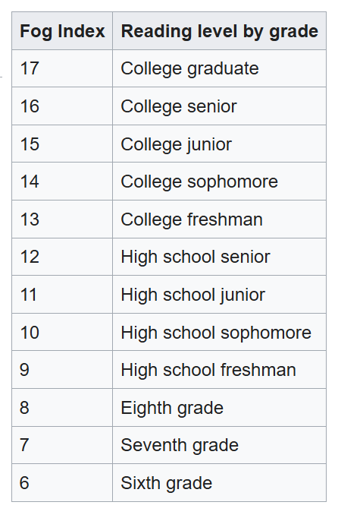

**Figure 8. Gunning Fog Index Reading Level Table**

*(Source: “Gunning Fog Index,” Wikipedia (2024))*

From this table, we can see that the ideal score is between 12 and 17, where all scores below 12 are below college level (but no penalty), and all scores above 17 are at a postgraduate level (-10 penalty).

3) A list of found sections with confidence scores

4) A list of found sections

5) Recommendations explaining what the syllabus should include for each missing item

The GUI simply prints this final output to the text box. Since everything is already formatted in the backend, the GUI does not need to process or rearrange any text.

GUI Design

Our GUI for the Syllabus Checker was designed to be easy to use by professors and university staff. It was designed using the Tkinter toolkit, which was easy to integrate with our backend. The GUI imports the backend by using “from Syllabus_Checker_For_GUI import check_syllabus,” which calls upon the main syllabus analysis function. Stylistically, we aimed to make the GUI look clean and organized to promote the true functionality of our program. When the application is launched, it launches a Tkinter window with the title of our program at the top. The design of our GUI was specialized for Penn State professors, by using the school colors as a theme for the interface and the Penn State logo in the corner.

The GUI features three core buttons, “Select PDF,” “Analyze,” and “Save Report.” The “Select PDF” button will open up a file explorer window that allows the user to select the syllabus they wish to analyze. Only files in PDF file format are available for selection in the file explorer, as the program rejects other file types. Once a file is selected from the file explorer, it will be loaded in the program. The syllabus may then be analyzed by pressing the “Analyze” button. When the user clicks Analyze, the GUI calls check_syllabus(self.file_path) and prints the returned report into the text box. The GUI runs the analysis process in the background, so that the GUI can remain operational while this is being performed. This is to prevent crashes when a user clicks or scrolls during analysis. The PDF analysis also runs with threading . This prevents the GUI from freezing while the CrossEncoder model loads and processes the text. The output is displayed in a text box at the bottom of the application labeled “Syllabus Analysis Report.” Within this text box, the user can scroll through the printed report. The report may also be saved to the user’s computer by pressing the “Save Report” button. This calls upon the save_report_as_pdf() function, which copies the text to a canvas and applies manual word-wrapping. After the function runs, the program will open up a small window that asks the user what they would like to name the file and where on their computer they want to save it.

The top of the GUI contains two buttons, “About” and “Help,” that list additional information when pressed. The “About” button displays the developers of our program and that it was created for this class, CMPSC 487W. The “Help” button provides step-by-step instructions on how to use the program. It also shares a link to the Penn State Faculty Handbook, which contains information on syllabus requirements.

Output Format

The output that appears in our GUI’s text box contains the syllabus analysis. Information derived from the file name is listed at the top. This includes the professor’s name, as well as the course’s name, number, and intended semester. The “Content Analysis Report” follows this, listing each section and whether or not they were found. A qualitative overall grade is then given based on a numeric score only seen in the backend. The grades that appear in the GUI are “Excellent,” “Great,” “Good,” “Adequate,” and “Incomplete.” This specific part of the output is also color coded, so that it may stick out when viewing the report. The readability report is present below this section, which assesses the quality of the writing based on three criteria: “Clarity and Flow,” “Appropriate For Course Level,” and “Word Choice and Complexity.” Under each of the listed criteria, the program displays what is done well and what is not, as well as gives a more tangible description of what each of the criteria means. This is done by calling the Flesch Reading Ease, Flesch Kincaid Grade Level, and Gunning Fog Index transformers from our backend. At the end of the program output, we implemented a “kudos” system, which congratulates the professor on what their syllabus has done right. We aimed to not be too critical in the analysis of a syllabus, so we designed the output to end with positive feedback.

**5.2 Required Tools and Technologies**

Our project is built using Python 3.11, which provides the ecosystem needed for text extraction, semantic analysis, and GUI development. The current version of the Syllabus Checker is implemented as a desktop application using Tkinter, enhanced with threading to ensure the interface remains responsive while long analyses run in the background. This replaces the earlier Streamlit prototype and gives users a faster, more stable, fully local tool.

For PDF processing, the system uses PyPDF to extract raw text from uploaded syllabi. The core detection engine combines two techniques: semantic similarity and keyword pattern matching. Semantic detection is powered by the Sentence-Transformers CrossEncoder model, which allows the program to recognize required syllabus sections even when instructors use non-standard phrasing. Pattern detection is improved further with intelligently designed strong-marker dictionaries and threshold tuning performed during testing.

To measure clarity and accessibility, the project integrates Textstat, which calculates readability metrics such as Flesch Reading Ease, Flesch-Kincaid Grade Level, and the Gunning Fog Index. These scores help evaluate whether a syllabus is written in a way that is appropriate for its course level and student audience.

The program also uses supporting libraries such as NumPy for numerical operations and Python’s built-in re module for sentence parsing and text normalization. For exporting results, ReportLab is used to generate clean, professional PDF reports directly from the application. Together, these technologies allow the Syllabus Checker to deliver accurate section detection, clear readability insights, and a polished user workflow within a unified, efficient desktop environment.

**5.3 Development Timeline**

* **Week of September 23: Acquire PSU Guidelines and Recommendations**

We will start by reviewing all syllabus policies and guidelines from the Penn State Abington Faculty Handbook (2025-2026) to understand what is required in a syllabus, as well as look into and review what is recommended to be included in a syllabus by Penn State.

* **Week of September 30: Review Sample Syllabi**

We will then review sample syllabi to identify common features and formatting. This will help us build a flexible template that our program can use as reference. This will include training a machine learning model to identify aspects of syllabi that may be slightly different in presentation, but adequate in content, such as labels like “How I Grade” substituting the ‘official’ “Grading Policy”.

* **Week of October 7, 14: Build the First Version of the Program**

Using the template, we’ll create a program that can scan a syllabus and rate it based on its readability, whether it meets PSU Abington’s requirements, and overall user-friendliness.

**October 16:** Present project updates to the class.

* **Week of October 21, 28: Improve Program**

We have built on our initial program and added many new features, alongside a fully operational GUI. The current state of the program is near completion, only requiring a few more tweaks.

* **Week of November 6, 11: Add Final Improvements and Features**

The last features and improvements that are needed to be added, and any suggestions from our client will be done here. We will also begin testing and refining our program’s search system throughout testing.

**November 6:** Present project updates to the class.

* **Week of November 13, 18: Finalize program**

This was the week that fully finalized the features and program functionality, before we prepared to send it to our client.

* **Regular Check-ins with Client**

We met with our client, Dr. Judy Ozment, every two to three weeks to ensure that we are on the right track and that the project meets Dr. Ozment’s expectations.

**Final Testing and Presentation**

* Week of Dec 2, 4: Final Project Presentation
* Week of Dec 9, 11: Submit final project package, including:
  + Final Project Report (PDF)
  + PowerPoint Presentation Slides (PDF)
  + Evaluation Letter from Dr. Ozment
  + Source code or link to source code with instructions for running program

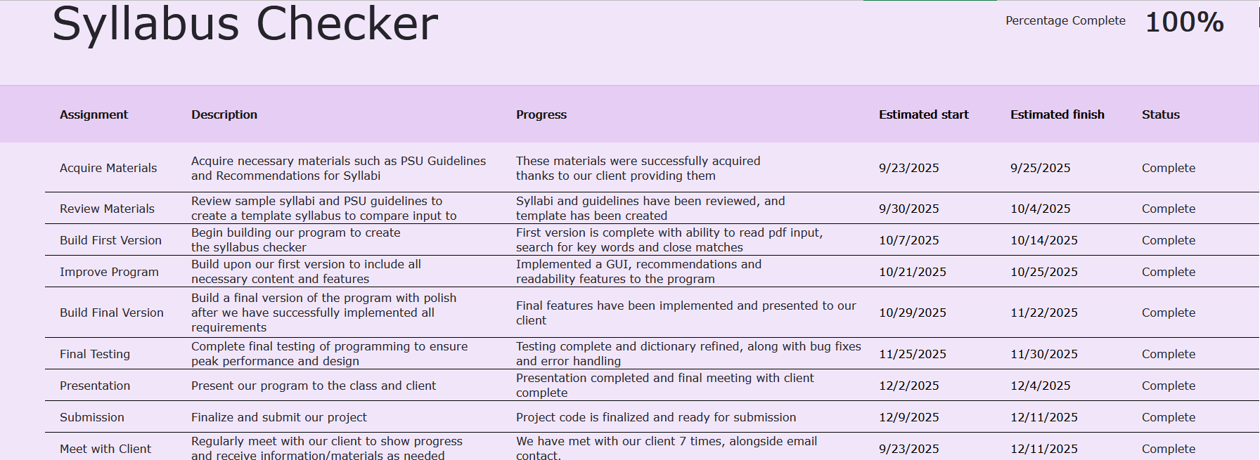

**Figure 9. Syllabus Checker Project Work Plan**

This figure is a screenshot of a chart showing our Syllabus Checker project work plan and progress.

## 

## **SECTION VI: Test Strategy Applied**

We created an excel spreadsheet to keep track of our test cases and code issues: [Syllabus Checker - Test Cases and Error Handling.xlsx](https://pennstateoffice365-my.sharepoint.com/:x:/g/personal/rzn5202_psu_edu/IQDz2Wa5rh8SQbP_q51gTo1dAS8Ff9WB69emDLIdMLZ7KYc?email=msh5850%40psu.edu&e=2KkbqP)

**6.1 Unit Testing**

Unit Test - Tests will verify that individual program components work correctly before integration. Major modules to be tested include:

* PDF extraction - confirm readable text is obtained from uploaded files
* Sentence parsing & cleaning - verify text is properly segmented and filtered
* Content detection - ensure required syllabus sections are correctly identified
* Readability assessment - validate scoring for Flesch and Gunning Fog
* Spell checking - confirm detection of misspellings and exemptions
* Scoring logic - verify points and penalties are calculated properly

Unit testing will occur continuously, with failures logged and corrected before integration.

**6.2 Integration Testing**

Integration Test - Testing will ensure that modules operate correctly when combined. Key integrations include:

* PDF -> text -> analysis pipeline
* Model scoring -> content evaluation -> recommendations
* Backend -> GUI display + threading
* Filename parsing -> metadata reporting

Testing will take place as components are merged. Issues discovered during integration will be documented and resolved to ensure smooth system behavior.

**6.3 System Testing**

System Test - Once the software has been completed, we will run a system test to ensure everything works as expected. The main areas we will test are:

1. Functional Testing:

* Check that the program can load different PDF files
* Check that the program will not accept non PDF files
* Make sure analysis runs without crashing
* Confirm that the GUI prints the full report correctly

1. Usability / Learnability Testing:
   * Have friends/classmates try the GUI
   * Ensure that the GUI is clear to navigate and output is easy to read
   * Confirm that error messages make sense to end-user
2. Accuracy Testing:
   * Test multiple syllabi from different departments
   * Check if the program correctly detects required sections
   * Compare the output to manual checks

## **SECTION VII: Discussion**

**7.1 Unresolved Issues**

While the system is fully functional within its current scope, several unresolved issues remain that limit its overall effectiveness and long-term scalability. These issues do not constitute critical failures but rather represent areas of partial implementation or complexity that exceeds the current architecture.

A notable challenge is the occurrence of false positives during analysis. This often arises when the system encounters content that superficially resembles a required section but does not fulfill its intended purpose. Such misclassifications are particularly common in syllabi that deviate from standard formats or utilize non-traditional language, thereby reducing the model’s ability to accurately infer instructional intent.

The quality of PDF text extraction also continues to pose a significant limitation. While some documents are processed cleanly, others exhibit structural inconsistencies such as broken sentences, missing whitespace, or character encoding issues. The current system is not equipped to repair or reinterpret poorly extracted text, which directly impacts the accuracy of the analysis.

Moreover, the analyzer operates on a sentence-by-sentence basis. Although this method offers computational efficiency, it restricts the system’s ability to understand content distributed across multiple sentences or identify sections that are implied rather than explicitly labeled. This constraint limits the depth of contextual interpretation and may result in overlooked or misidentified components.

From a user interface perspective, several usability concerns persist. The report interface requires substantial vertical navigation in longer documents, and it lacks advanced features such as section anchors, collapsible result groups, or a global search function to expedite review. These limitations reduce operational efficiency, particularly for users processing multiple syllabi.

Finally, the application does not incorporate any form of adaptive learning. Errors identified during use cannot be retained to improve future performance unless manual adjustments are made to keyword lists or threshold values. This lack of persistence prevents iterative refinement and limits the tool’s responsiveness to user feedback.

Collectively, these unresolved issues point to design and technical areas where future development could yield substantial improvements.

**7.2 Limitations**

Several of the Syllabus Checker’s limitations arise not from flaws in implementation but from intrinsic constraints related to the tools employed and the nature of the source materials. These constraints define the boundaries within which the system can operate effectively.

Syllabi are inherently diverse in structure, content, and tone. They vary across instructors, departments, and institutions, and often reflect individualized formatting choices or pedagogical styles. Consequently, the analyzer’s performance is dependent on the degree to which input documents conform to recognizable patterns. In cases where the document structure is unfamiliar or idiosyncratic, the semantic model may fail to interpret the content correctly, even if the information is present.

The underlying machine-learning model also carries fundamental limitations. Unlike a human reader, the model does not possess a conceptual understanding of language; it operates on statistical correlations. As a result, ambiguous, fragmented, or multifunctional sentences can lead to uncertain or inaccurate classifications.

Readability metrics represent another area of constrained applicability. Tools such as the Flesch Reading Ease or Gunning Fog Index are optimized for evaluating general-purpose English prose. When applied to syllabi which often contain technical jargon, bullet lists, grading rubrics, or institutional policy language these metrics may yield misleading results. High difficulty scores do not necessarily imply a problem with clarity, but rather a mismatch between the document type and the evaluation method.

The limitations of PDF formatting also present persistent challenges. While some files export clean, linear text, others include embedded fonts, complex layouts, or formatting codes that interfere with reliable parsing. The analyzer does not interpret visual structure, and therefore cannot accurately process content embedded in tables, sidebars, footers, or graphical elements.

Finally, the system is stateless and context-independent. Each document is evaluated in isolation, with no memory of past inputs, instructor preferences, or institutional guidelines. This lack of cross-document continuity further constrains the system’s adaptability.

Together, these limitations delineate the operational scope of the current tool and suggest the importance of continued refinement if broader applicability is to be achieved.

**7.3 Future Work**

Future development of the Syllabus Checker presents multiple opportunities to enhance its analytical capabilities, adaptability, and user experience. The following directions are proposed to address the limitations identified in earlier sections and to expand the system’s overall utility.

One area for improvement is the design of the detection pipeline. Transitioning from sentence-level analysis to paragraph- or multi-sentence-level segmentation would allow the system to capture context more effectively. This modification would enhance the model’s ability to identify sections that are expressed in narrative form or distributed across several lines of text.

Enhancing the text preprocessing stage is also a priority. Improvements in normalization particularly for documents with non-standard formatting and the inclusion of optional optical character recognition (OCR) would increase the system’s robustness when handling PDFs that extract poorly or contain structural anomalies.

From a user interface perspective, several enhancements could substantially improve usability. Proposed features include collapsible result categories, embedded navigation tools to jump between sections, and an integrated search function within the analysis report. These upgrades would streamline the review process and reduce cognitive load for users managing large or multiple documents.

Long-term improvements could also include comparative functionality. Enabling users to analyze multiple syllabi side by side or to track changes across semesters would add value for both instructors and academic administrators. Additionally, incorporating a lightweight feedback mechanism could allow the system to learn from user corrections. For example, if a section is manually reclassified, the tool could store this adjustment and adjust its detection parameters in subsequent analyses.

Finally, extending the system’s ability to interpret structured layouts such as tables, multi-column formats, or sidebars would significantly expand its analytical reach. This could involve advanced parsing techniques or integration with layout-aware extraction tools.

These enhancements represent a strategic roadmap for future iterations of the Syllabus Checker and would contribute meaningfully to its accuracy, flexibility, and user adoption.

## **SECTION VIII: Conclusion**

The Syllabus Checker project resulted in the development of a practical tool designed to help instructors review and improve their syllabi. By combining text extraction, readability analysis, and automated policy detection, the system offers a clear assessment of which required components are present, which may need further attention, and how accessible the document is for students. What began as a simple concept evolved into a fully functional application capable of analyzing a wide range of syllabi with consistency and efficiency. In the process, our team gained valuable experience across the full software development lifecycle—from initial design and program architecture to user interface refinement and model evaluation.

Throughout the project, the importance of iteration became clear. Early versions of the analyzer struggled with inconsistent formatting and vague language, but repeated testing and feedback allowed us to improve rule sets, strengthen detection logic, and increase the system’s reliability. These refinements deepened our understanding of how machine learning behaves on real academic documents and how to adapt a system when faced with unpredictable inputs. While the current tool performs effectively, there remain clear opportunities for future improvement, including OCR support for scanned PDFs, enhancements to the semantic model to reduce false positives, and interface upgrades to support more intuitive navigation.

Looking ahead, the application has the potential to be extended into a web-based platform or integrated with instructor feedback systems to enable adaptive learning. These developments could make the tool even more responsive and scalable across departments or institutions.

Ultimately, the Syllabus Checker demonstrates how a focused software project can deliver meaningful value to both faculty and students. It automates a task that is often time-consuming and subjective, and it offers structured, objective feedback that can help raise the overall quality and clarity of course syllabi. Beyond delivering a working product, the project strengthened our team’s skills in practical problem solving, collaboration, and the application of machine learning in a real-world context.

**REFERENCES**

*Penn State Abington Faculty Handbook 2025 - 2026*

[*Syllabus Requirements*](https://senate.psu.edu/faculty/syllabus-requirements/)

[*43-00 Syllabi | University Faculty Senate*](https://senate.psu.edu/students/policies-and-rules-for-undergraduate-students/43-00-syllabi/)

*CMPSC 487W: Software Engineering and Design Syllabus*

[*Grammarly: Free AI Writing Assistance*](https://www.grammarly.com/?msockid=2a3c34364751602b36ff224746c561c4)

[*sentence-transformers · PyPI*](https://pypi.org/project/sentence-transformers/)

[*Pretrained Models — Sentence Transformers documentation*](https://sbert.net/docs/cross_encoder/pretrained_models.html)

[*RapidFuzz · PyPI*](https://pypi.org/project/RapidFuzz/)

[*Flesch–Kincaid readability tests - Wikipedia*](https://en.wikipedia.org/wiki/Flesch%E2%80%93Kincaid_readability_tests)

[*Flesch Reading Ease and the Flesch Kincaid Grade Level – Readable*](https://readable.com/readability/flesch-reading-ease-flesch-kincaid-grade-level/)

[*Gunning fog index - Wikipedia*](https://en.wikipedia.org/wiki/Gunning_fog_index)

[*textstat · PyPI*](https://pypi.org/project/textstat/)

## **SECTION IX: Appendix**

**Appendix A – ReadMe / Installation Instructions**

# Overview

This program is designed to allow users to input a PDF syllabus and analyze it using our algorithms, which will grade the document based on found required sections and readability score. The program will produce a report of recommendations and kudos based on what is found and not found, and what is determined as readable or inadequate. This program utilized sentence transformers and Fleish-Kincaid readability scoring to determine the grading of an input syllabus.

# Installation and Usage

The user should install all packages in the requirements.txt file, and then run SyllabusChecker.py. Alternatively, you can download the exe file with the link provided, and simply run that file alone. After this, the user can upload a syllabus with the Upload File button on the program, and select their PDF syllabus from the file explorer. Once selected, the user can press Analyze and wait for the program to produce a report. After the report has loaded, the user can select Save Report to save the produced report as a PDF file of their own. The user can select the Upload File button again to upload another syllabus if they desire and repeat the process.

**Appendix B – Software Snapshots**

Snapshots: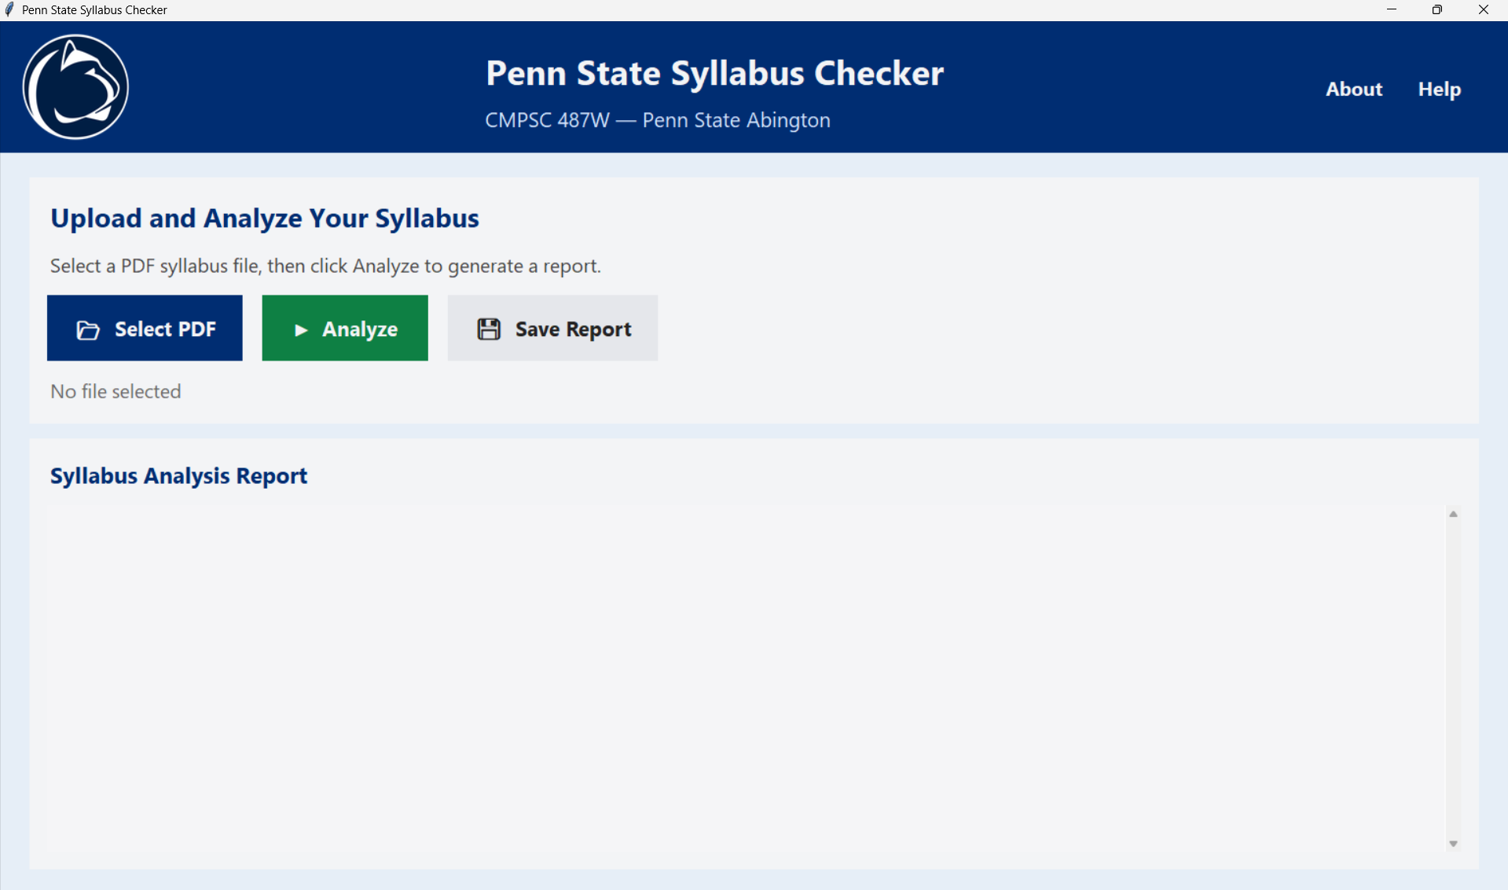

**‘**

**Figure 10. Default Screen of the Program**

This is a screenshot of the default screen of the program once it is opened. A PDF must be selected before any analysis occurs.

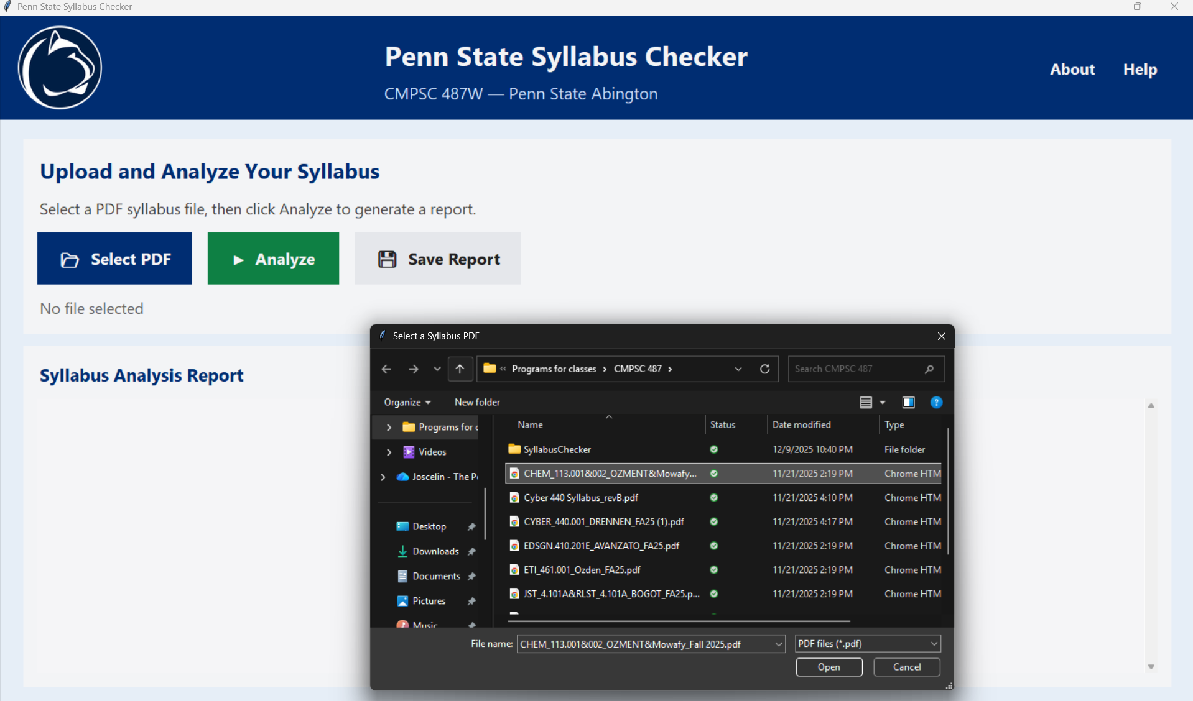

**Figure 11. Selecting File**

This photo shows that after clicking “Select PDF,” a File Explorer window is opened, to which a syllabus PDF can be selected.

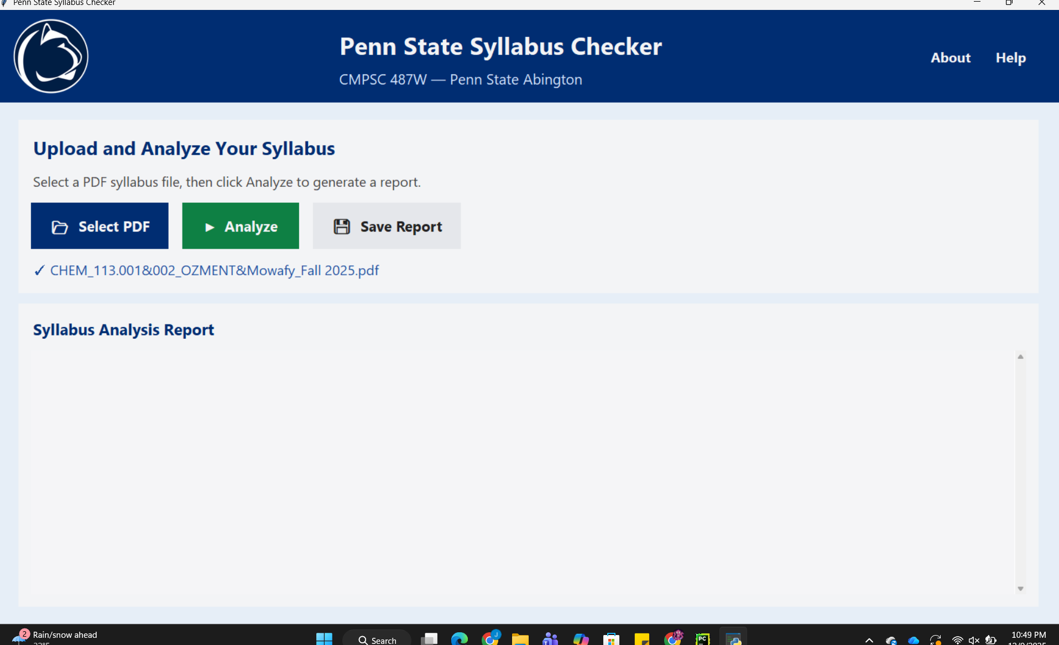

**Figure 12. Loading File**

This figure shows a syllabus will be loaded into the program after being selected. Then, the user may press “Analyze Syllabus” to begin the analysis process.

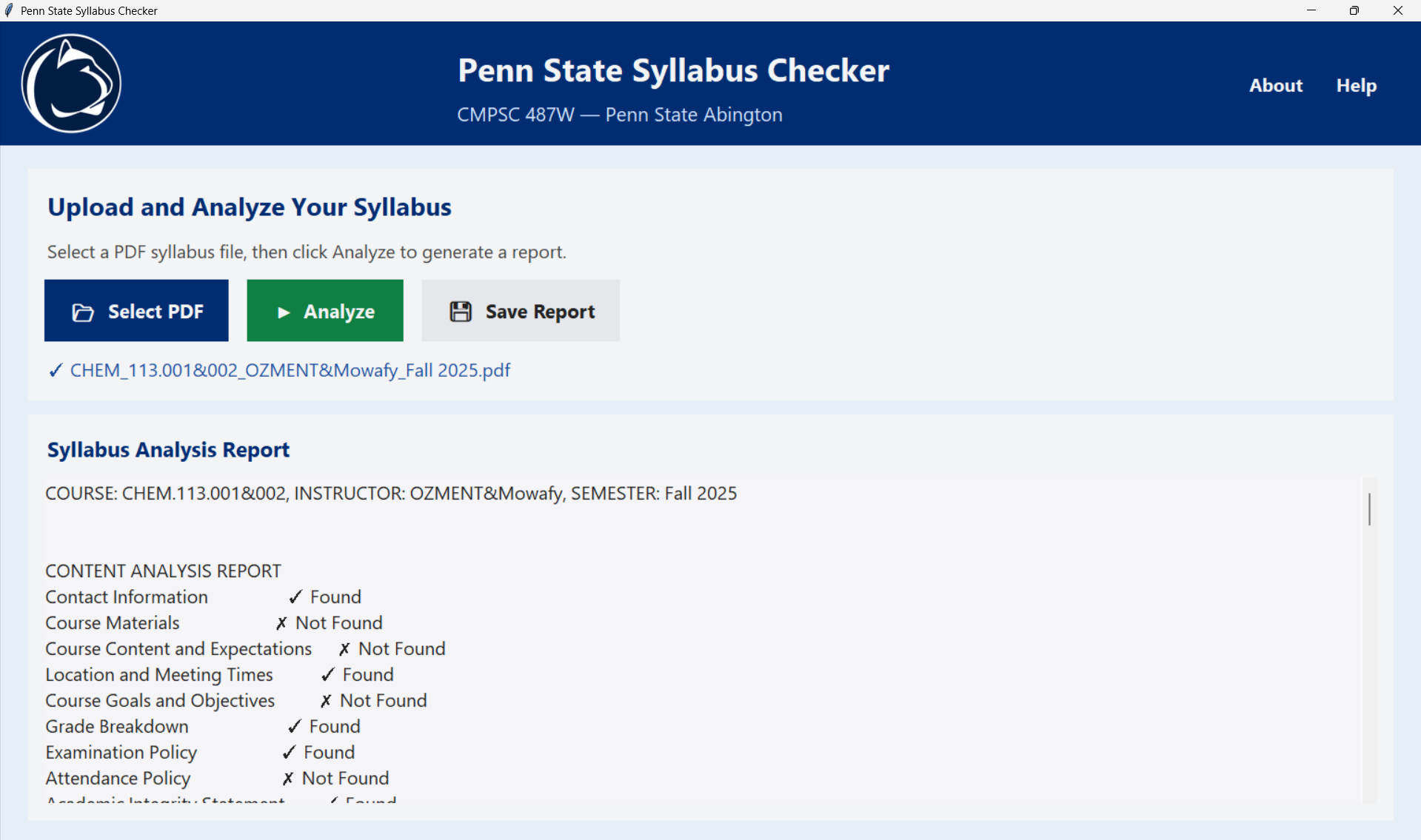

**Figure 13. Initial Content Analysis Report Generated by the Syllabus Checker**

This figure shows the program’s first-stage analysis, including the uploaded PDF information and the list of syllabus sections detected or missing.

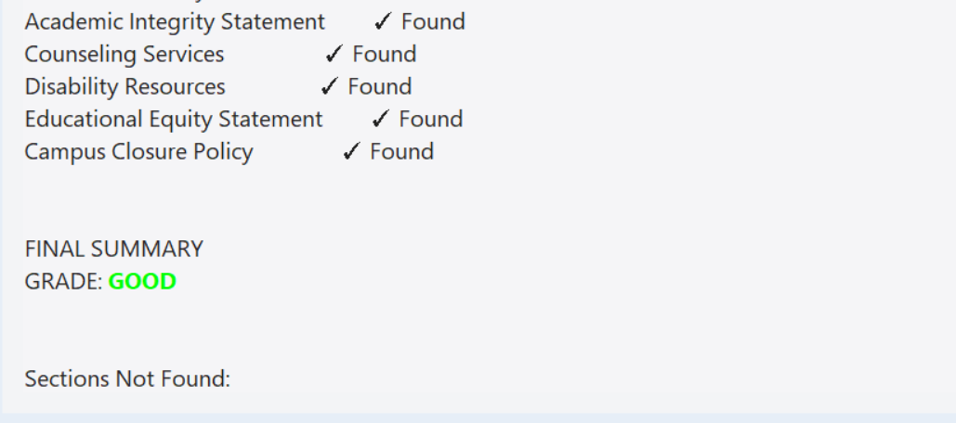

**Figure 14. Summary of Detected Sections and Overall Syllabus Grade**

This figure displays the final summary of which required sections were found and the overall grade assigned by the syllabus checker based on content completeness.

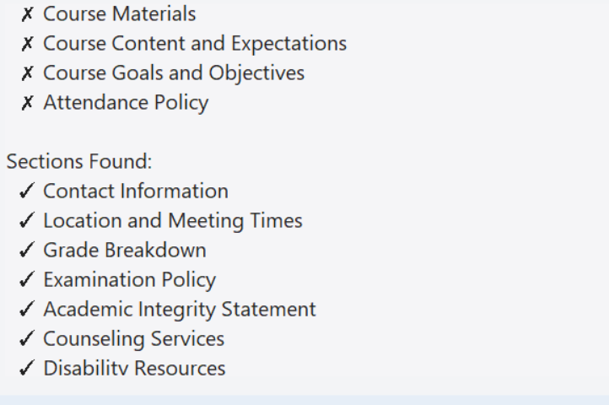

**Figure 15. Detected and Missing Syllabus Sections**

This figure displays the syllabus sections the program successfully identified, as well as the sections that were not found during the content analysis.

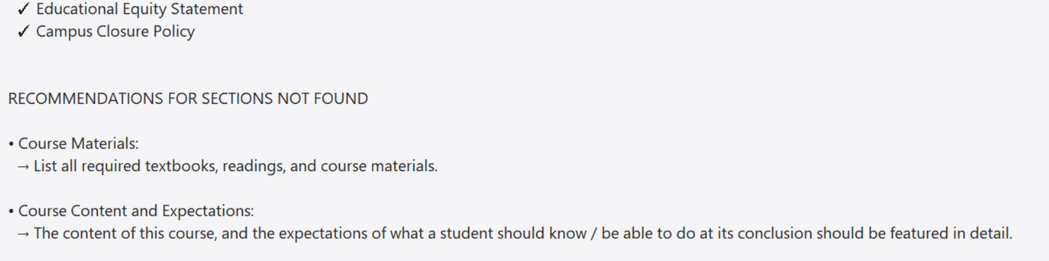

**Figure 16. Recommendations for Missing Syllabus Sections**

This figure shows the program’s suggestions for improving the syllabus by adding required sections that were not detected in the uploaded document.

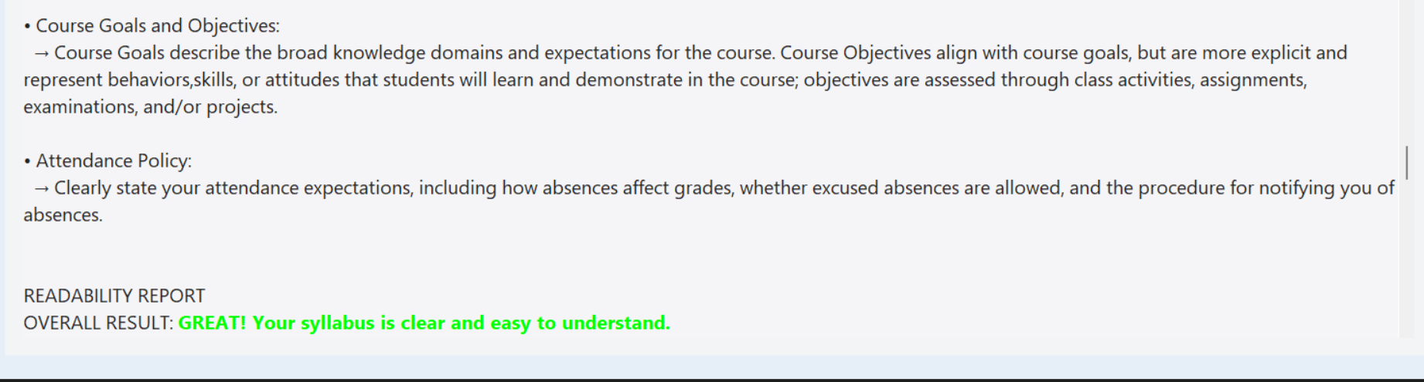

**Figure 17. Readability Report Overall Evaluation**

This figure highlights the program’s overall readability assessment, indicating that the syllabus is clear, well-structured, and easy for students to understand.

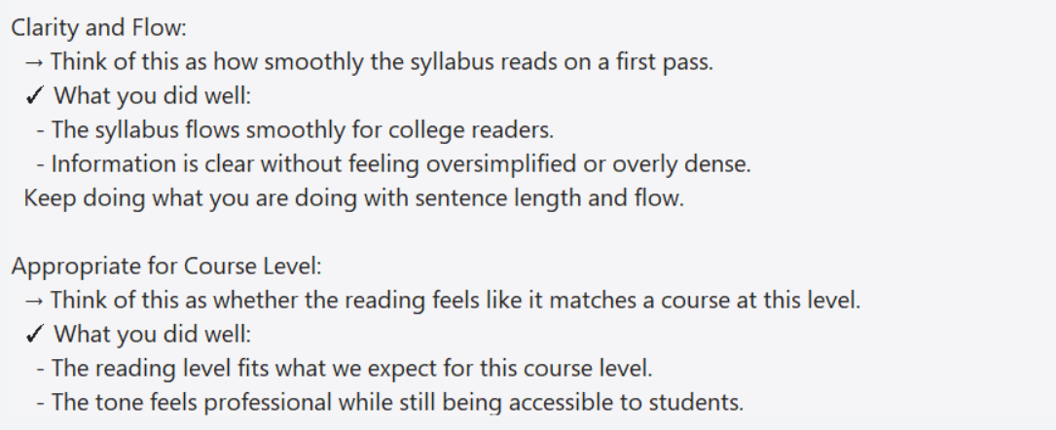

**Figure 18. Clarity Assessment**

This figure shows the program’s readability evaluation, including the overall result and detailed feedback on clarity, flow, and how well the syllabus reads on a first pass.

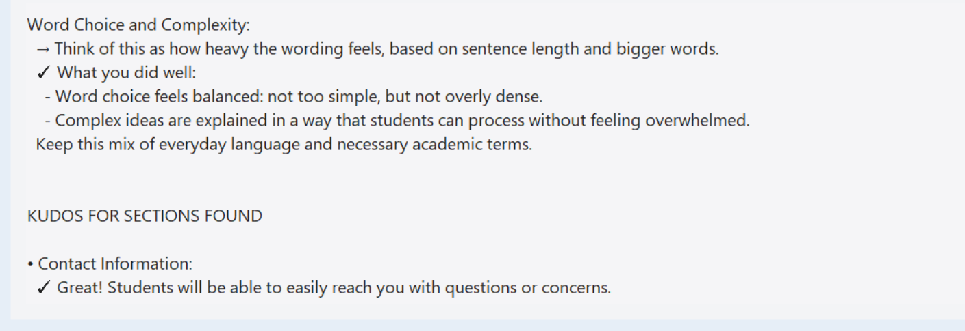

**Figure 19. Feedback on Word Choice, Complexity, and Section Strengths** This figure displays the analysis of word choice and complexity in the syllabus, along with positive feedback for sections that met the expected standards.

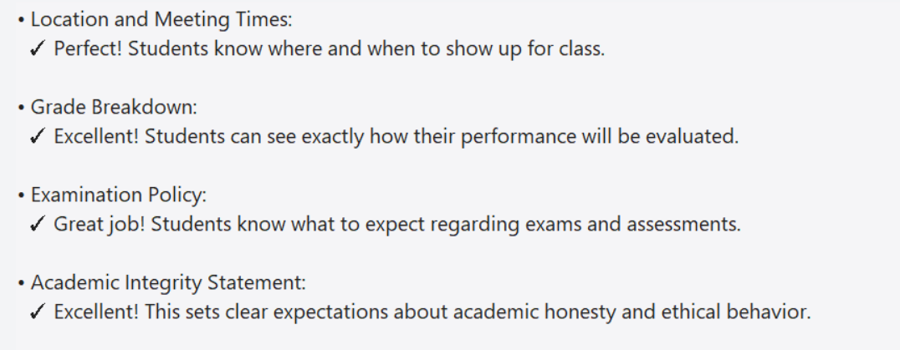

**Figure 20. Positive Feedback for Successfully Detected Syllabus Sections**

This figure shows the program’s detailed remarks for syllabus sections that met expectations, providing positive confirmation for areas such as meeting times, grade breakdown, examination policy, and academic integrity statements.

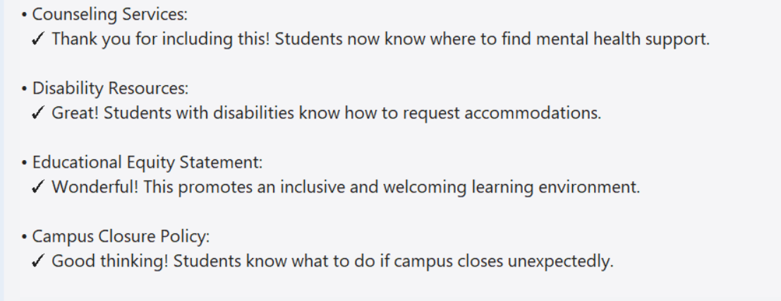

**Figure 21. Feedback on Student Support and Policy Sections**

This figure presents the program’s positive feedback for sections related to student services and campus policies, including counseling services, disability resources, educational equity, and campus closure procedures.

The output windows details which sections were found and which were missing. The quality of found sections are also judged, shown by the “Readability Report.” Recommendations appear at the bottom of the window, for possible improvements to be made in the syllabus.

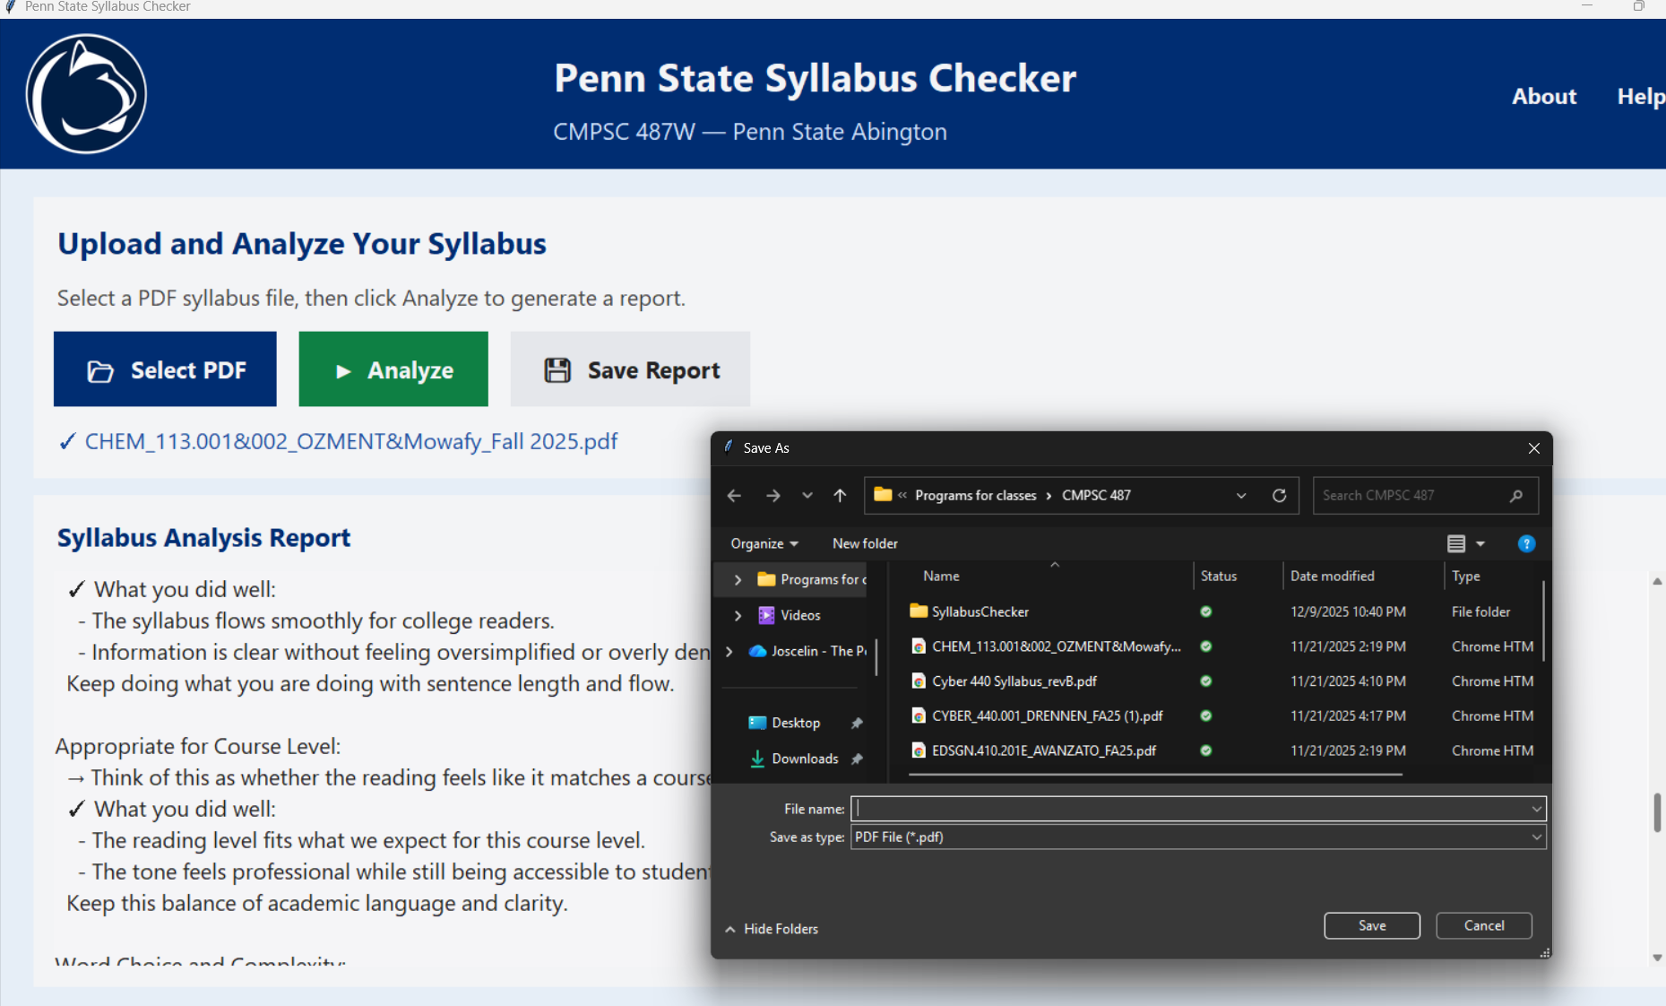

**Figure 22. Saving the Generated Syllabus Report**

This figure shows the “Save Report” functionality, where the user can choose a file location and export the syllabus analysis as a PDF document.

**Appendix C – Client Evaluation Letter**

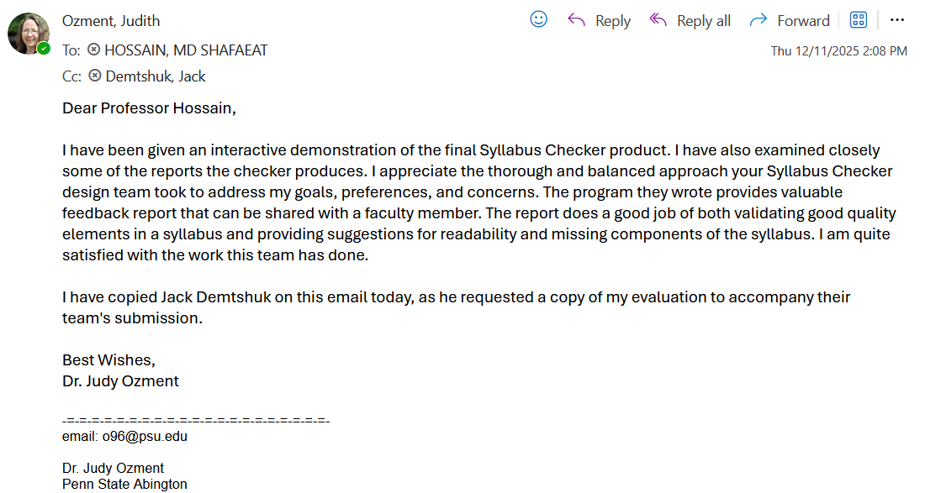

**Figure 23. Client Evaluation Letter**

This figure is a screenshot of Dr. Ozment’s evaluation of our Syllabus Checker project.